[Palace of the Shah, Teheran, Iran]
Possibly Luigi Pesce | 1840s–60s | Record IMG-WA0013

1. Original Image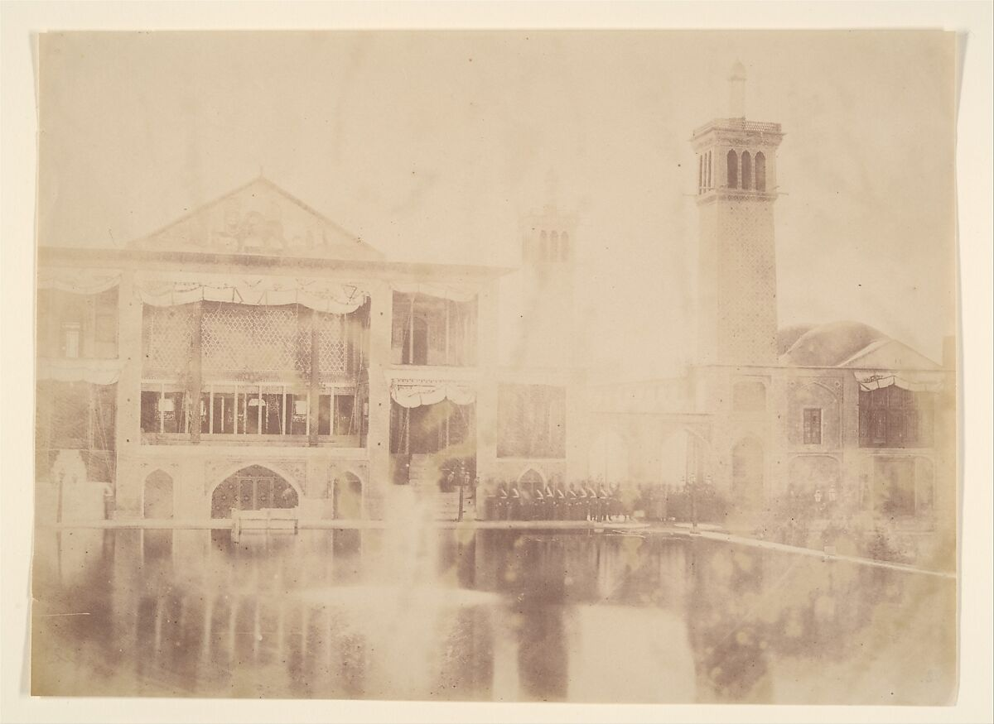
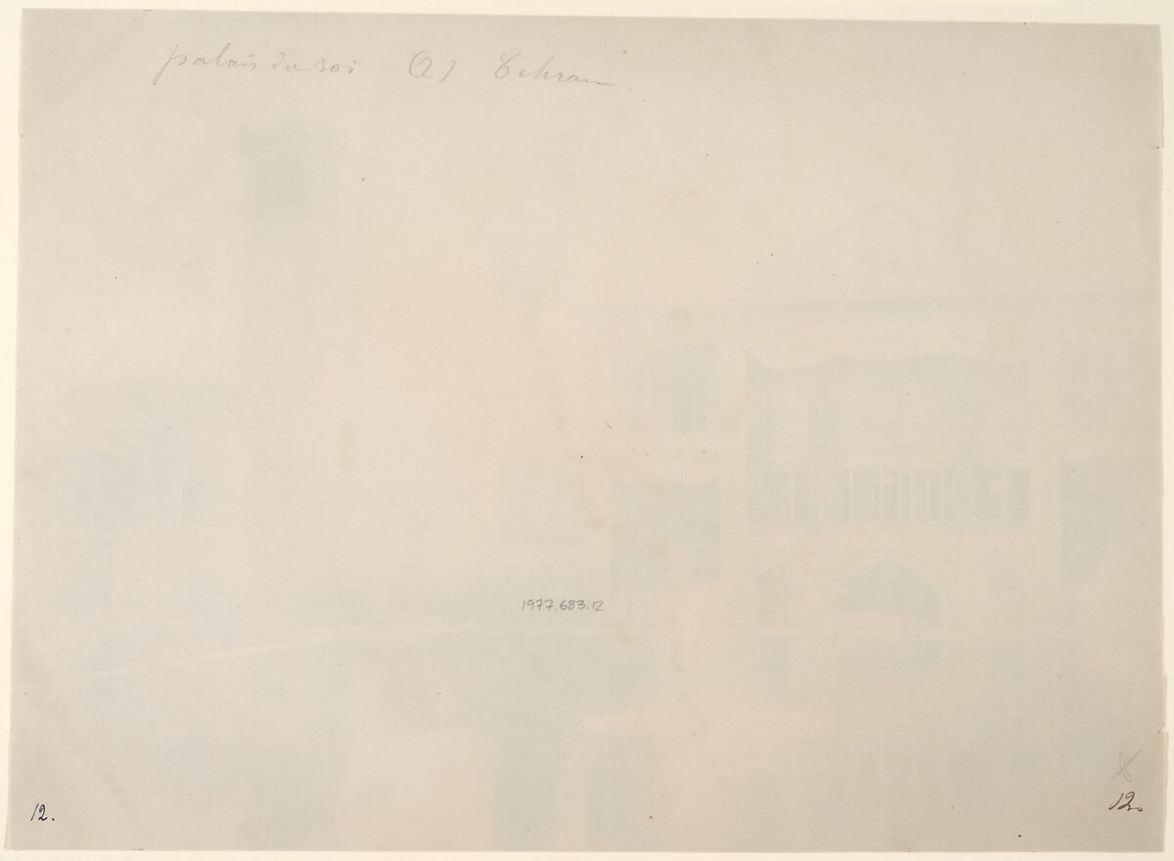

IMG-WA0013. Possibly Luigi Pesce, [Palace of the Shah, Teheran, Iran], ca. 1840s–60s. The Metropolitan Museum of Art.

2. Record Summary
Record ID | IMG-WA0013
Original title | [Palace of the Shah, Teheran, Iran]
English title | [Palace of the Shah, Teheran, Iran]
Alternative title | N/A
Creator | Possibly Luigi Pesce
Creation date | ca. 1840s–60s
Country | Iran
Cultural region | West Asia; Tehran
Historical period | Qajar Iran; early architectural photography
Image type | Photography
Medium | Not verified
Dimensions | Not verified
Primary subject | Palace complex and reflecting pool
Secondary subjects | Arched pavilion, tower, dome, trees and reflections
Source institution | The Metropolitan Museum of Art
Collection or object number (optional) | 1977.683.12

3. Image Description

3.1 Short Description
A pale and substantially faded photograph shows a palace complex beside a reflecting pool. An open arched pavilion stands at the left, while a tall narrow tower and a domed structure rise toward the right. Low contrast makes smaller architectural and landscape details difficult to distinguish.

3.2 Detailed Visual Description
A broad body of still water occupies much of the lower half and reflects parts of the architecture. At the left, a two-level pavilion includes a row of open arches beneath a pitched roof. A narrow tower rises near the centre-right, with small openings and a projecting upper section. A lower domed building appears farther right.
Dark tree forms cluster around the architecture and provide some separation from the nearly blank sky. The waterline and reflections create broad horizontal bands, but fading and uneven density soften many edges. No people or animals can be identified with confidence. The strongest visible forms are the pavilion, tower, dome and diffuse reflections.

4. Formal Features
Field | Analysis
Composition | Horizontal arrangement of water and palace buildings, interrupted by a vertical tower.
Viewpoint or camera angle | Distant view across the pool.
Shot scale | Wide architectural landscape.
Spatial depth | Water, buildings and trees form shallow layered depth.
Lighting | Difficult to determine because of fading.
Colour palette | Pale yellow-beige and faint brown.
Contrast | Very low.
Visual focus | Arched pavilion and tower.
Texture | Architectural surfaces are softened by deterioration.
Movement or stillness | Static view with still reflections.
Medium-specific features | Severe fading and uneven image density.

5. Historical Context and Purpose

5.1 Historical Context
The Met attributes this photograph only tentatively to Luigi Pesce and provides a broad date range of the 1840s–60s. The bracketed title identifies the site as a palace of the shah in Tehran, but the Museum does not list a verified photographic process or dimensions. The image belongs to the earliest decades of photography in Qajar Iran, when court and architectural settings became subjects for the new medium. Image Purpose and Circulation

5.2 Image Purpose and Circulation
Original purpose: Not verified.
Probable purpose: Architectural documentation, possibly associated with an album, court record, private circulation or travel documentation.
Current institutional use: Preservation as an early photograph associated with Iran.

